Your Details |  |  | Next of Kin (emergency contact)
Full Name |  |  | Full Name
Address |  |  | Address
Postcode
Date of birth / / |  |  | Relationship to you
Telephone/Mobile |  |  | Telephone/Mobile
Email
Additional information
Are you currently involved in other form/s of exercise?  If yes, please state. | Yes  No | Have you done any running before? |  |  | Yes  No
 |  | How did you find out about the group?
Health and disabilities
Do you have any health considerations we ought to know about? |  | Yes No  If YES, please explain
Disability Category
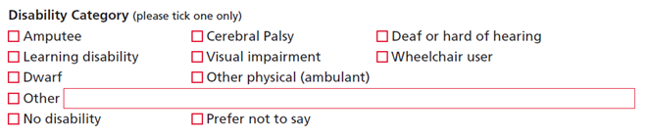
Do you suffer from any of the following?  (please tick) |  |  |  | Diabetes |  |  | High Blood Pressure
 |  |  |  | Heart problems |  |  | Joint problems
 |  |  |  | Back pain |  |  | Asthma
Any condition requiring medication:
Other conditions including previous injuries (please detail)
Declaration – please read the declaration below and confirm that you agree
Date  Registration Form- Affiliation to UK Athletics - £12 fee for April 2015 to April 2016.  Name: Date of Birth: / /  Address:  Date: | Sign

